5 Best Practices for Working with Enzymes for Tissue Dissociation
Luke Doiron on Jun 3, 2015 10:03:39 AM
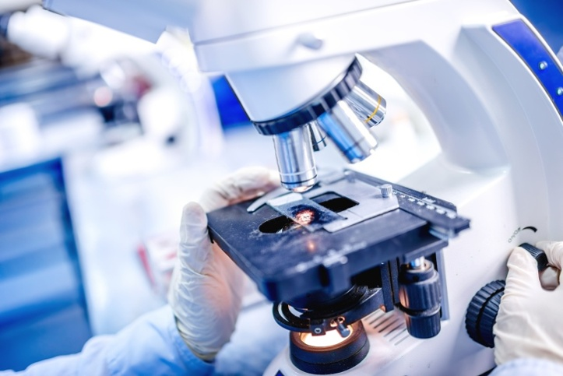
Biomedical research frequently relies on high-quality tissue specimens that are then enzymatically dissociated into single cell preparations. These cells are useful for a wide range of studies, such as gene expression profiles or analysis of cell surface markers, as well as for growing cell cultures using an isolated primary cell. Successful tissue dissociation with enzymes is affected by a variety of factors which can impact cell viability, yield, and ultimately, clinical usefulness.
Researchers sometimes struggle to optimize the conditions for tissue dissociation and so see variations in their data. Most controllable variations can be traced to these factors: the dissociation medium utilized, enzyme(s) selection, impurities in crude enzyme preps, enzyme concentration, temperature and incubation time. These are all important parameters that need to be defined and optimized for your specific research project in order to achieve both high yields and high cell viability.

Here are some suggestions if you're struggling with yield and viability:
- Low yield/low viability - Likely a result of too aggressive dissociation, causing cell damage. Consider switching to an enzyme with less digestive strength, and/or decrease your enzyme working concentration. For example, switch from trypsin to collagenase or from type 2 collagenase to type 1.
- Low yield/high viability - In this situation, it's likely that you're not dissociating thoroughly either because your enzymes are too mild or your incubation time is too short; or it might be some combination of the two. Try increasing your enzyme concentration or incubation time and evaluate your yield and viability. You may need to use a stronger, more digestive enzyme or add another enzyme to aid in tissue dissociation.
- High yield/low viability - You're likely using the enzyme in too high of a working concentration; or the enzyme you've selected is too strong (too digestive) and so is causing cell damage. In this situation, reduce the concentration and/or incubation time, then monitor your yield and viability. You might also try to decrease the proteolytic activity of your enzyme by diluting it with a 0.1 to 0.5% concentration of BSA or you might add a soybean trypsin inhibitor in a 0.01 to 0.10% concentration to your dissociative mixture.
Of course, obtaining both a high yield and high viability is your ultimate goal, so work toward this outcome by adjusting some of the key dissociation parameters mentioned earlier.

Here are a few other tips for optimizing your enzyme tissue dissociation process:
- If working with lyophilized enzymes, be aware that lyophilized proteins are typically hygroscopic, so don't open them in a humid environment. Make sure any such vials are brought to room temperature before opening. Reconstituted enzymes should not be stored between 2 and 8°C, but rather frozen at -20°C (after aliquoting if desired).
- Trituration (cell dispersion through mild pumping action) after incubation in dissociation enzymes often helps with primary cell isolation. However, if done too aggressively, cell destruction and lower viability can result. Use a gentle filling/emptying rate of approximately 3 ml/second.

